COMSATS University Islamabad

Linear Circuit Analysis

Lab No. 02

Introduction to Breadboard and LT-spice Software

|  |  |
| --- | --- |
| Name | ALI ZAR /Ali Haider |
| Registration Number | FA24-BCE-019 / FA24-BCE-018 |
| Class | BCE-1A |
| Instructor’s Name | Sir Ahsan Khawaja |

Date: 18th September 2024

Introduction to Breadboard:

1.Objective:

The purpose of this lab is to learn about breadboards Breadboard is used to build and test circuits without soldering, in this lab, we will learn how breadboard t works and use them to create simple circuits

1. Breadboard:
   1. What is Breadboard?

A breadboard is a tool that helps you quickly build circuits by connecting electronic components like resistors, LEDs, and wires without permanently joining them. The board has many small holes where you insert these components. It’s great for testing circuits because you can easily change parts or connections if needed.

Main Uses:

* + - Building Circuits:

Breadboard makes it easy to put together a circuit without needing to solder components together.

* + - Testing Circuits:

You can try out your circuit to see if it works before building the final version.

* + - Learning:

Breadboard is commonly used in schools and labs to teach how circuits work.

* 1. How a Breadboard is Organized

A breadboard has two main parts:

* + Power Rails: These are long rows along the edges of the breadboard used to connect power (positive and negative) to your circuit.
  + Terminal Strips: These are the areas where you place your components like resistors or wires. The rows are connected internally so that parts in the same row are linked together.

BreadBoard:

To understand this, first you have to understand how a breadboard's holes are electrically connected. You can see the breadboard in figure 11 given below on which circuits are built. two rows of blocks A, D & G of breadboard are internally & separately horizontally connected from 0 to 30 after that there is no horizontal connection i.e. there is a gap after that, then again from 31 to 60 these 2 rows are internally & separately horizontally connected as show by arrows in blocks A, D & G of figure 1, 2 & 3 below. There is no internal connection between these two rows These two rows are mostly used for power connections when making circuit on breadboard. Blocks B, C, E&F are internally vertical connected as shown in figure 1, 2 & 3. These blocks are mostly used to place components to complete the circuit while making it on breadboard. Remember that there is no internal connection between Blocks A, B, C, D, E, F & G.

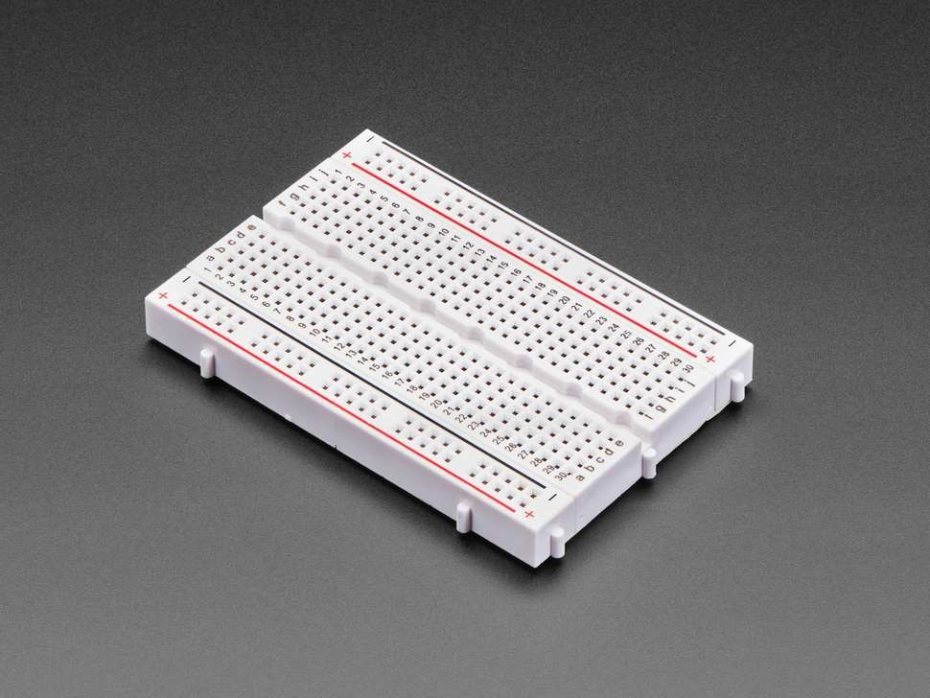

2.3 Breadboard Conclusion

Breadboards are very helpful because they let you quickly build and test circuits without soldering. They are easy to use, allow for changes, and are great for learning how circuits work.

LTspice Software:

3.1 What is LTspice?

LTspice is a free program that lets you design and test circuits on your computer. Instead of building a real circuit, you can draw it in LTspice and see how it would work. This helps you understand if the circuit will function as expected before creating it in real life.

3.2 How LTspice is Used

* + Simulating Circuits: You can create a circuit using virtual components and see how it behaves when you run it in the software.
  + Testing Parts: LTspice has lots of different parts, like resistors, capacitors, and transistors, that you can add to your circuit to see how they work together.
  + Analyzing Waveforms: LTspice can show you graphs of how voltage or current changes over time in your circuit.

3.3 Circuit Diagrams in LTspice :

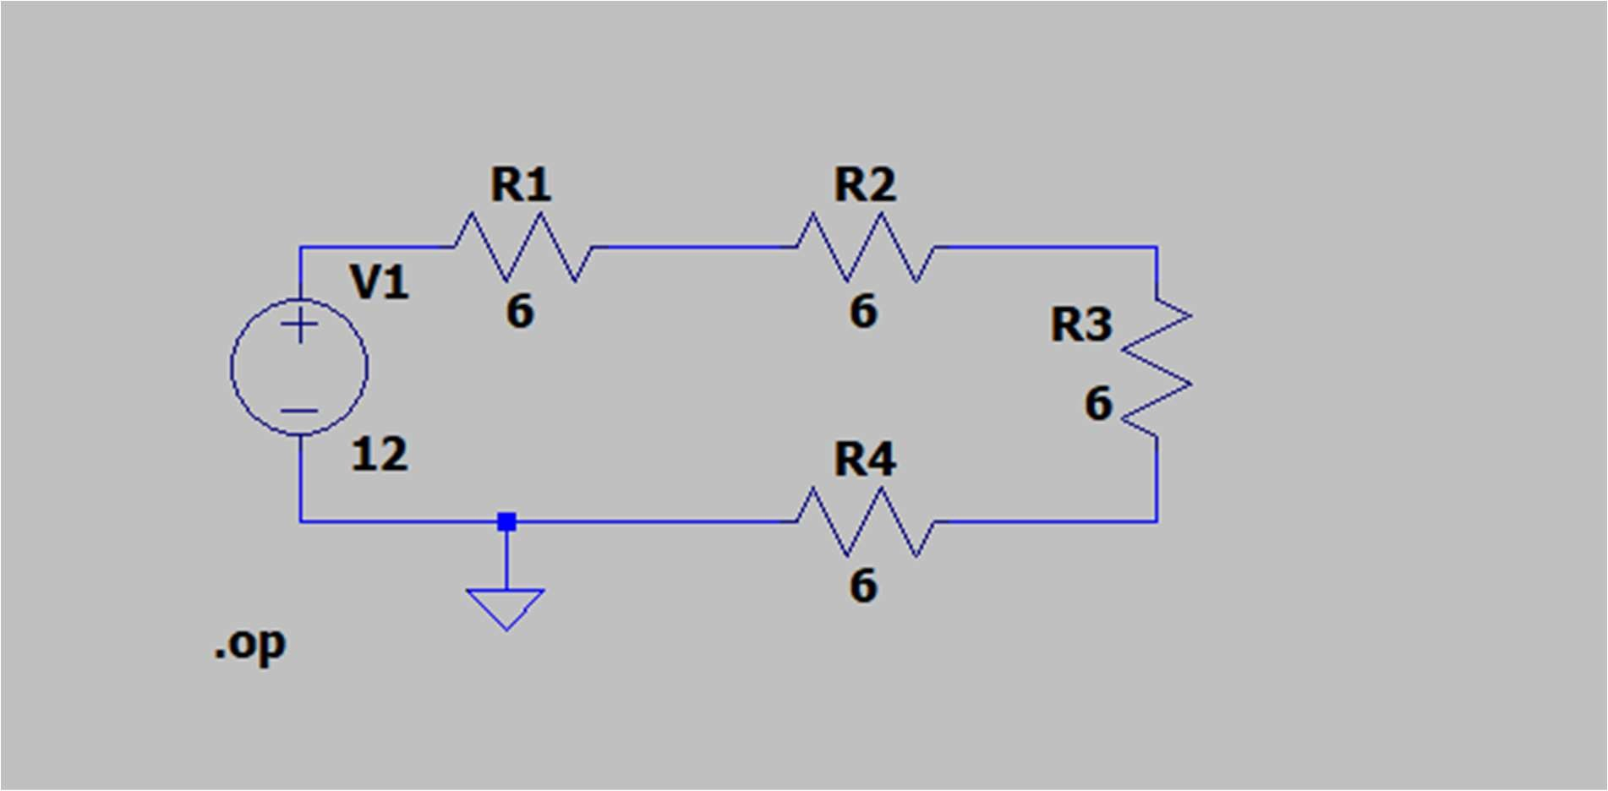

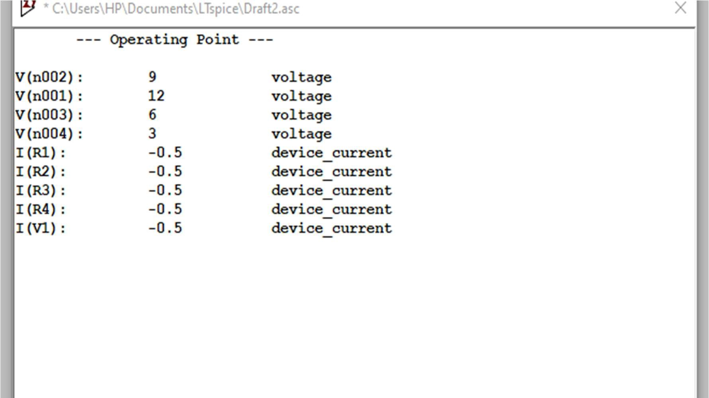

3.4 LTspice Conclusion

LTspice makes it easy to design circuits on your computer. It helps you see how your circuit would work and allows you to fix any problems before you build it. This saves time and makes learning about electronics easier.

4. Conclusion

In this lab, we learned about breadboards and LTspice. Breadboards are a quick and easy way to build and test circuits without using solder. LTspice lets us create circuits on the computer and simulate how they work. Together, these tools make it easier to understand electronics and try out different circuit designs.